**SSG API Testing Application**

User Guide

Contents

About this application 3

About This User Guide 3

Intended User 3

System Requirement 3

Acronyms and Abbreviations 3

Get Started 4

Installation 4

Setup – Setting 4

Components of the App 6

Courses 6

Course Run API 6

View Course Run 7

Add Course Run 8

Update Course Run 11

Delete Course Run 13

Course Session 14

Enrolments 15

Enrolment API 15

Create Enrolment 15

Update Enrolment 18

Delete Enrolment 19

Search Enrolment 20

View Enrolment 22

Update Enrolment Fee Collection 23

Attendance 24

Attendance API 24

Course Session Attendance 24

Upload Course Session Attendance 24

Assessment 24

Assessment API 24

Create Assessment 24

Update/ Void Assessment 24

Search Assessment 24

View Assessment 24

Additional Features 24

Decrypt and Encrypt information 24

Tooltip Description 24

Optional Field and Mandatory Field 24

# **About this Application**

## About this User Guide

The purpose of this document is to provide step-by-step instruction of how to use the SSG API testing application for understanding the requirements and usage of the APIs.

The application includes the function of the 15 mandated APIs that are under the TMS requirement.

This document aims to describe function of each component that allows the user to use the different functions such as add courses, do enrolment, submit attendance and assessment.

APIs to retrieve, update information relating to courses, training providers and administer programmes, grants, services for individuals.

## Intended User

The guide is intended for the user who have loaded the application and would like to start to attempt to use it.

## System Requirement

This app is only for Windows users

## Acronyms and Abbreviations

|  |  |
| --- | --- |
| **Acronyms** | **Acronyms Description** |
| SSG | SkillsFuture Singapore |
| TP | Training Partners |
| API | Application Programming Interface |
| UEN | Unique Entity Number |

# **Get Started**

## Installation

Go to: Github (URL)

There are 2 different types of installation guide:

1. Installation Guide (Exe) for Public User
2. Installation Guide for Developer

## Setup – Setting

1. Click on ‘Setting’ highlighted in Fig. 1

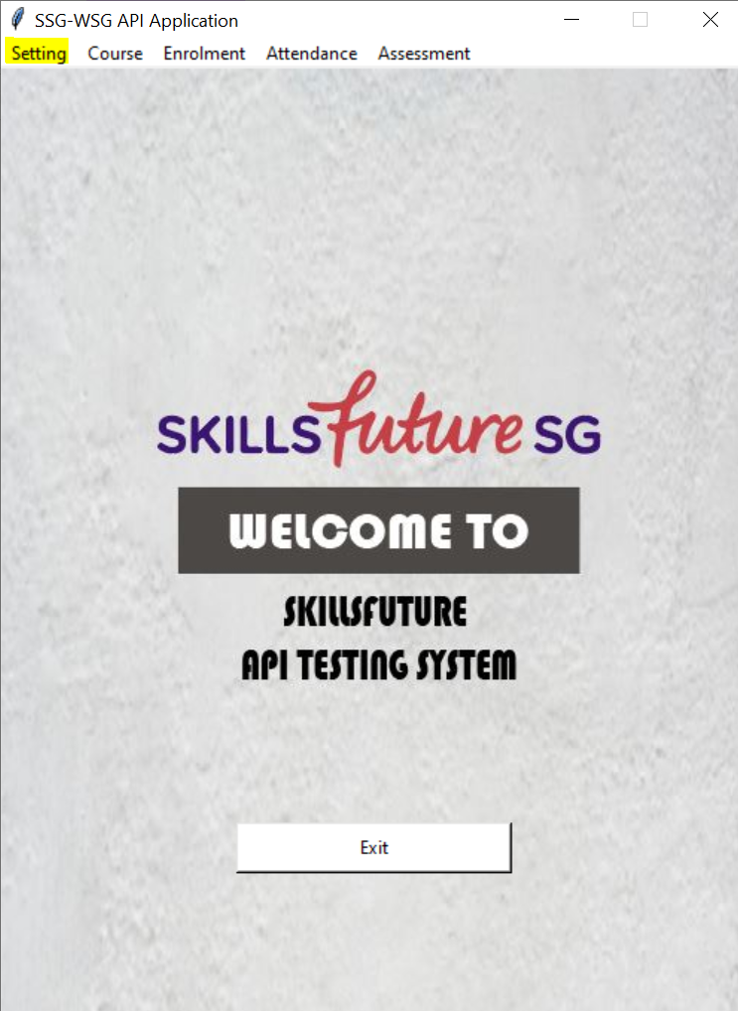

Fig. 1: Highlighted component set up - Setting in the application interface.

1. Click on Set Configuration and pop up window shown in Fig. 2 will be shown open

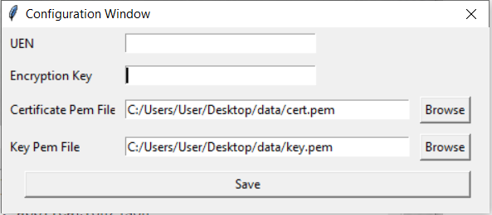

Click on save button to save the configuration window.

Click on browse button to retrieve ‘Key.pem’.

Click on browse button to retrieve ‘Cert.pem’.

Enter Encryption Key

Enter Company UEN no

Fig. 2: Configuration Window

*Refer to* [*Guide*](https://developer.ssg-wsg.gov.sg/webapp/guides/1kR6AzKYXtvPEXfXCZJHgu#3-digital-signature) *for how to get the Cert and Key pem file and Encryption Key.*

1. Fill up the empty fields and click ‘Save’.
2. Upon successful saving of details, the Success notification shown in Fig. 3 will pop up.

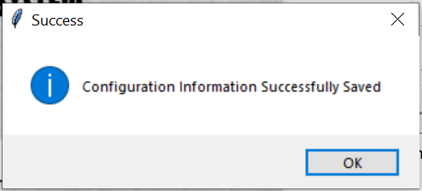

Fig. 3: Success notification for configuration

1. Click on ‘Show Configuration’ under Setting drop down menu to view what have been set in the Configuration window. (See Fig. 4)

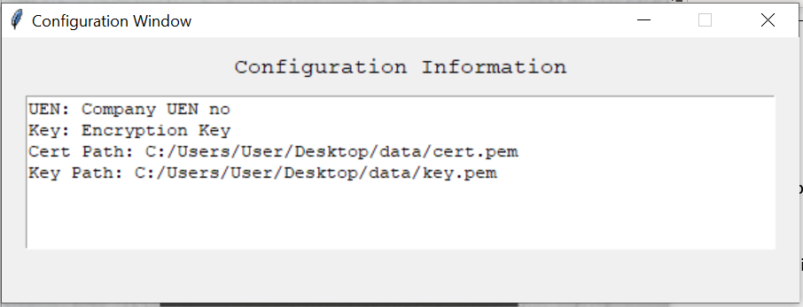

Fig. 4: Configuration Information window

# **Components of the App**

## 

## **Courses**

### Course Run API

The 4 APIs listed below under this category are implemented in the app. Update and Delete Course Run use the Delete Course Run API.

1. Course Runs By Run Id - This API is used to retrieve course run details by course reference number and course run ID
2. Delete Course Run - This API is used to delete course run
3. Course Sessions - This API is used to retrieve course sessions by course reference number, course run ID and month
4. Add Course Run - This API is used to publish course run(s) with sessions if any

Click on ‘Course’ at the top left-hand corner as shown in Fig. 5 to access Course APIs.

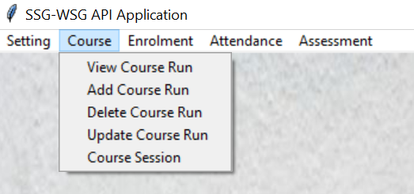

Fig. 5: Course Run APIs

The subsequent sections will take you through the steps needed to use these APIs in the app.

### View Course Run

1. Click on ‘View Course Run’ to open View Course Run window to view existing Course Run in the app, in Fig. 6.

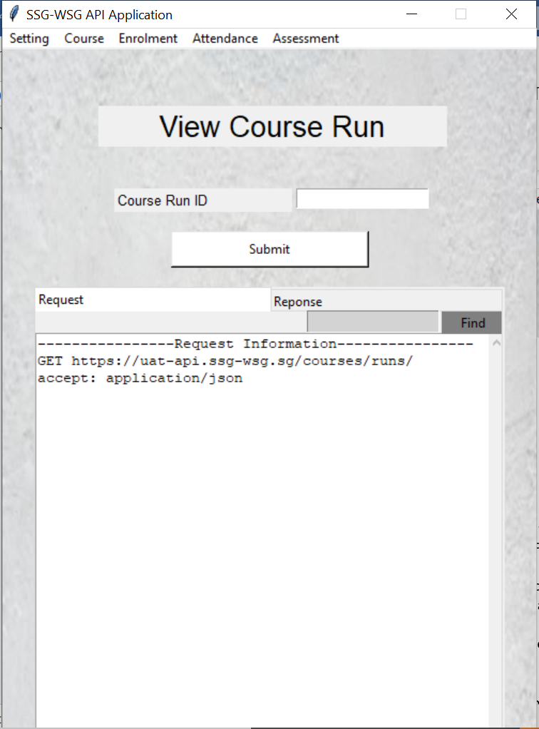

**3**

**2**

Fig. 6: View Course Run window

1. Key in the Course Run ID of interest and since this API is a GET Method, there is no payload information required.
2. Click on ‘Submit’ and see the response for Course Run details.

### Add Course Run

1. Click on ‘Add Course Run’ to open Add Course Run window to add new Course Run into the app as shown in Fig. 7.

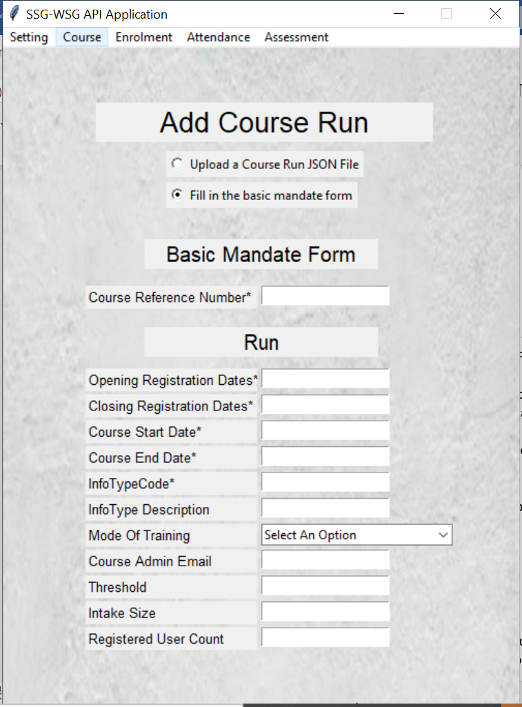

**2**

Fig. 7: Add Course Run window

1. Fill up the Request body information. Click on ‘Next’ once all the information is correctly filled in.

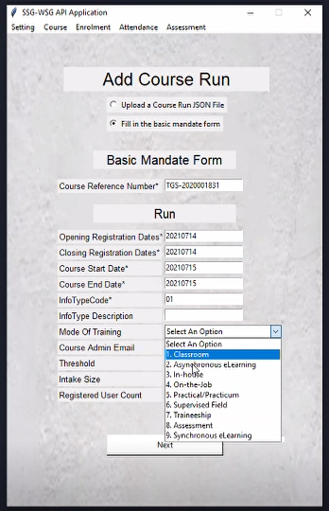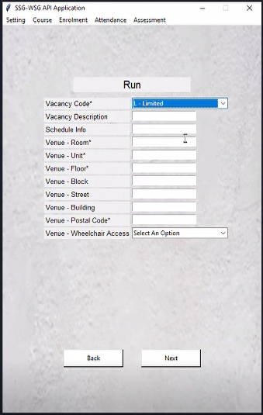

**2**

**2**

Fig. 8: Filling up the Request body.

1. There are two optional sections - Sessions and Trainers. You may choose to fill the information in if you have the details. Click on ‘Preview’ once you are done with these Optional Fields.

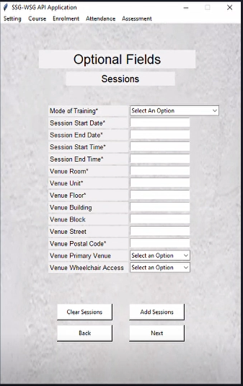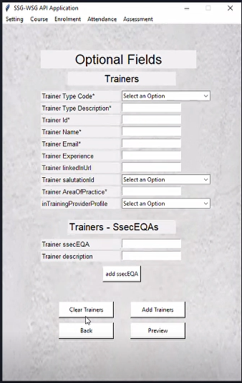

**3**

**3**

Fig. 9: Optional field

1. Click on ‘Create’ once you have ensured that all details of the Request Payload are accurate. Click on ‘Back’ if you have further edits to make.

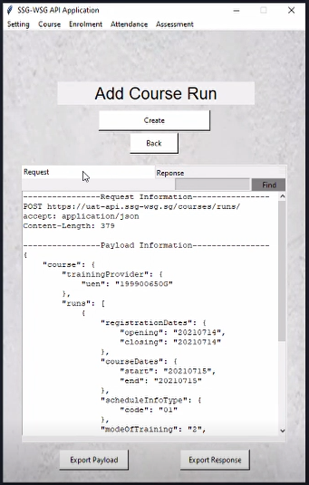

**4**

Fig. 10: Upon successful Create Course Run API

### Update Course Run

1. Click on ‘Update Course Run’ to open Update Course Run window to update existing Course Run in the app, in Fig. 11.

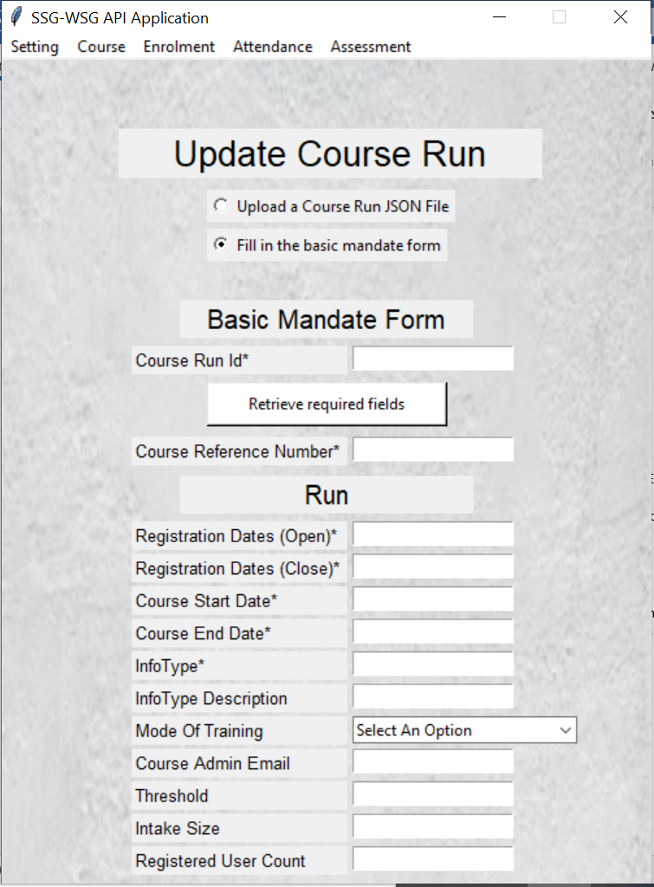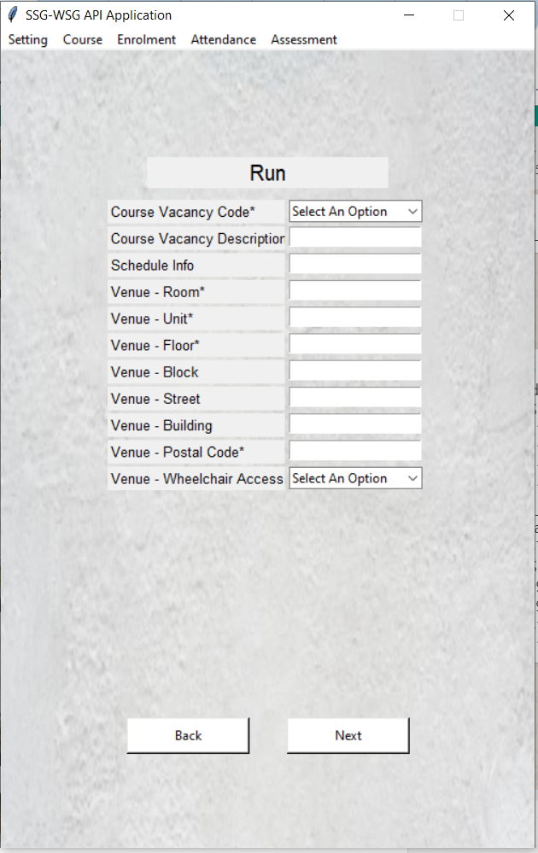

**2**

**2**

Fig. 11: Update Course Run API window

1. Fill up the updated Request body information. Click on ‘Next’ once all the information is correctly filled in.
2. There are two optional sections - Sessions and Trainers. You may choose to fill the information in if you have the details. Click on ‘Preview’ once you are done with these optional Fields.

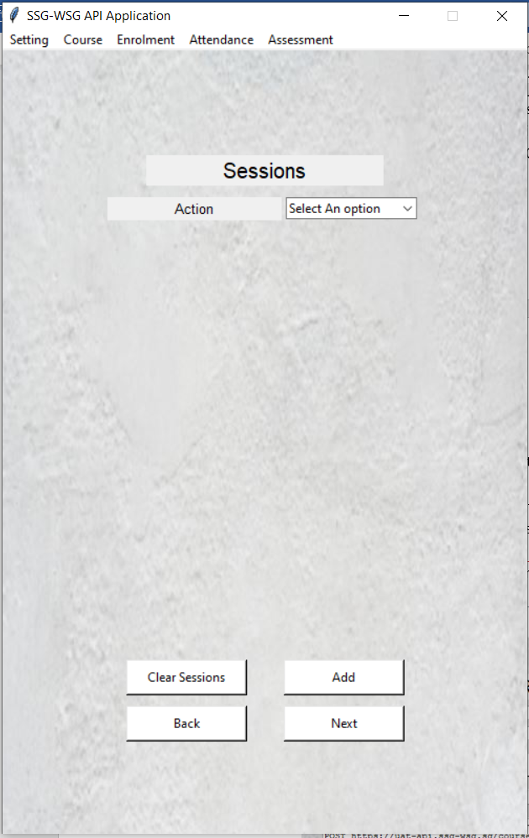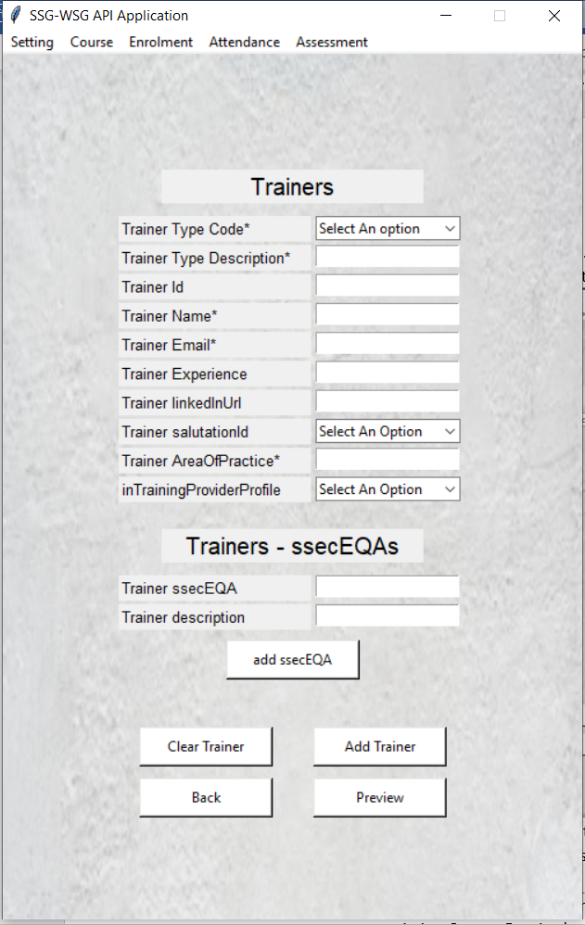

**3**

**3**

Fig. 12: The Optional Field

1. Click on ‘Update’ once you have ensured that all details of the Request payload are accurate. Click on ‘Back’ if you have further edits to make.

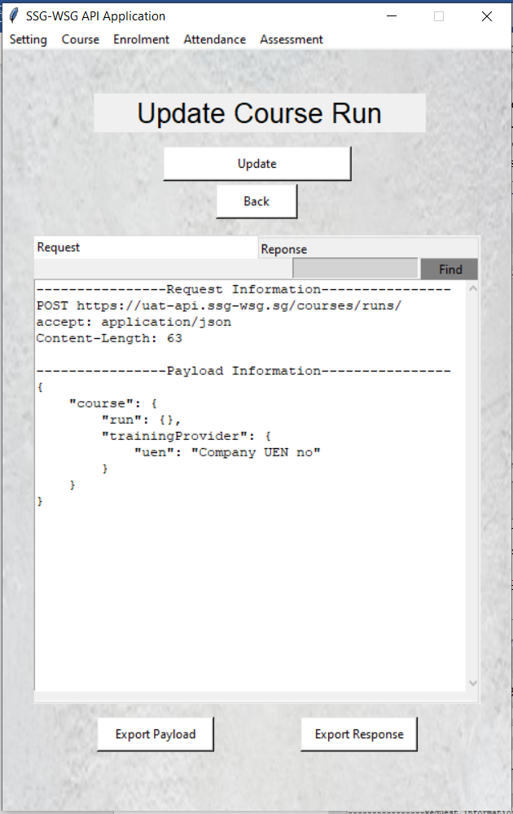

**4**

Fig. 13: Reviewing Request body for Update Course Run

### Delete Course Run

1. Click on ‘Delete Course Run’ to open Delete Course Run window to delete existing Course Run in the app

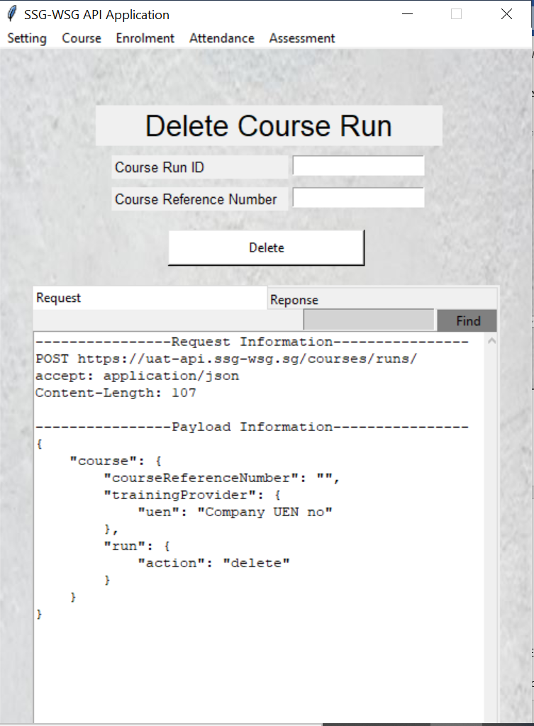

**3**

**2**

Fig. 14: Delete Course Run API window

1. Key in the Course Run Id and Course Reference Number of interest and since this API is a GET Method, there is no payload information required.
2. Click on ‘Delete’ to delete the course.

### Course Session

1. Click on ‘Course Session’ for View Course Session window in Fig. 15 to open.

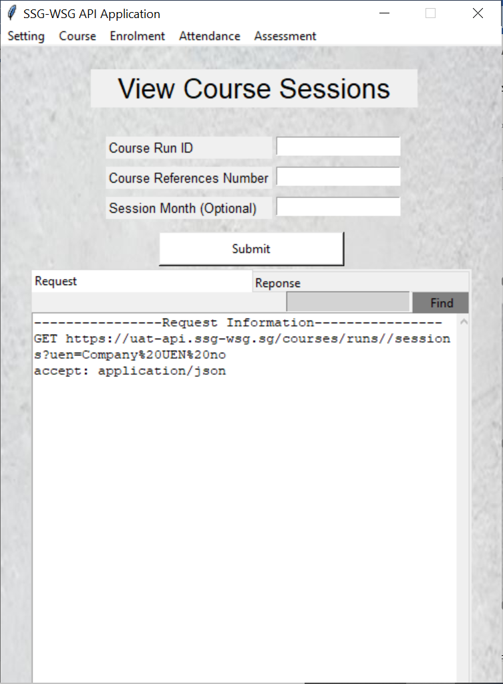

**3**

**2**

Fig. 15: View Course Session API window

1. Key in the Course Run Id and Course Reference Number of interest and since this API is a GET Method, there is no payload information required.
2. Click on ‘Submit’ to view the course sessions.

## **Enrolments**

### Enrolment API

The 5 APIs listed below under this category are implemented in the app.

1. Create Enrolment – This API is used to create an enrolment record
2. Update or Cancel Enrolment – This API is used to update or cancel an enrolment record
3. Search Enrolment – This API is used to search for enrolment record(s)
4. View Enrolment – This API is used to query a specific enrolment record
5. Update Enrolment Fee Collection – This API is used to update an enrolment record or set status to 'cancelled

Click on Enrolment at the top left-hand corner as shown in Fig. 16.

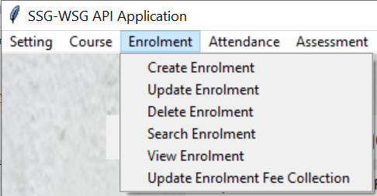

Fig. 16: Enrolment APIs

The subsequent sections will take you through the steps needed to use these APIs in the app.

### Create Enrolment

1. Click on ‘Create Enrolment’ for Create Enrolment window in Fig. 17 to open.

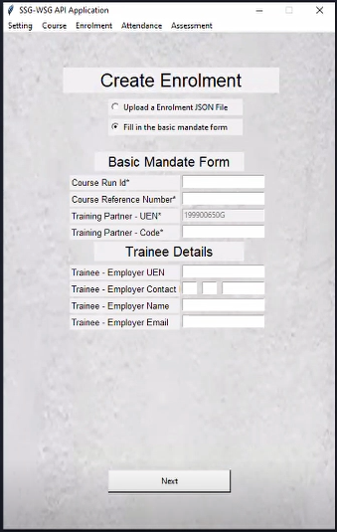

**2**

Fig. 17: Create Enrolment APIs window

1. Fill up the Request body information. Click on ‘Next’ once all the information are correctly filled in.
2. Fill up the rest of the Request body information. Click on ‘Next’ once all the information is correctly filled in.

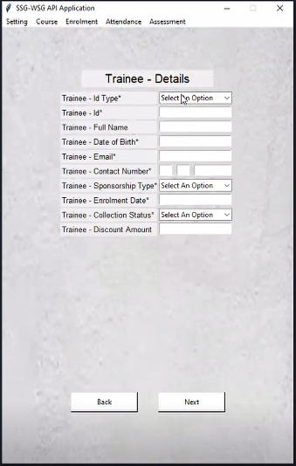

**3**

Fig. 18: Create Enrolment API request body

1. Click on ‘Create’ once you have ensured that all details of the Request payload are accurate. Click on ‘Back’ if you have further edits to make.

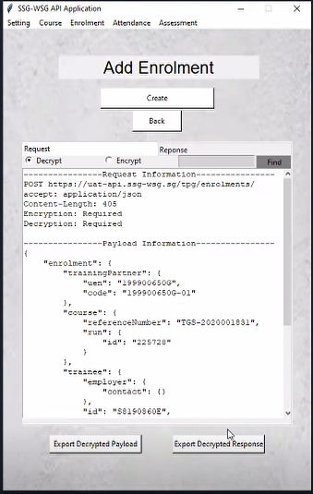

**4**

Fig. 19: Create Enrolment preview page

### Update Enrolment

1. Click on ‘Update Enrolment’ for Update Enrolment window in Fig. 20 to open.

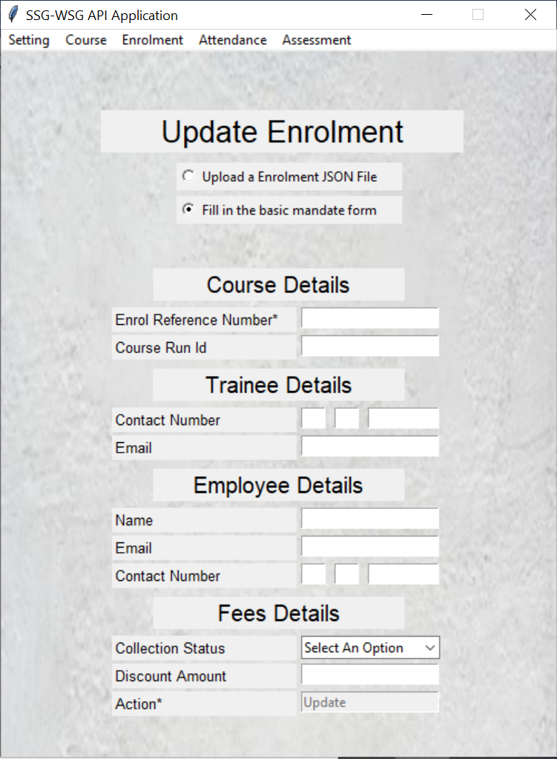

**2**

Fig. 20: Update Enrolment API window

1. Fill up the Request body information.
2. Click on ‘Update’ once you have ensured that all details of the Request payload are accurate. Click on ‘Back’ if you have further edits to make.

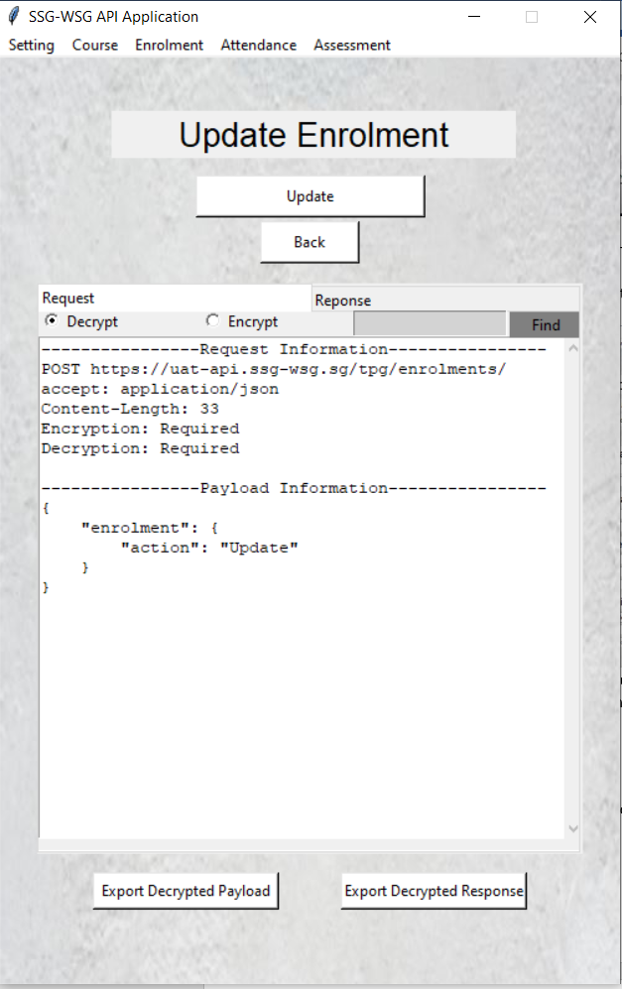

**3**

Fig. 21: Update Enrolment API Request body preview page

### Delete Enrolment

1. Click on ‘Delete Enrolment’ for Delete Enrolment window in Fig. 22 to open.

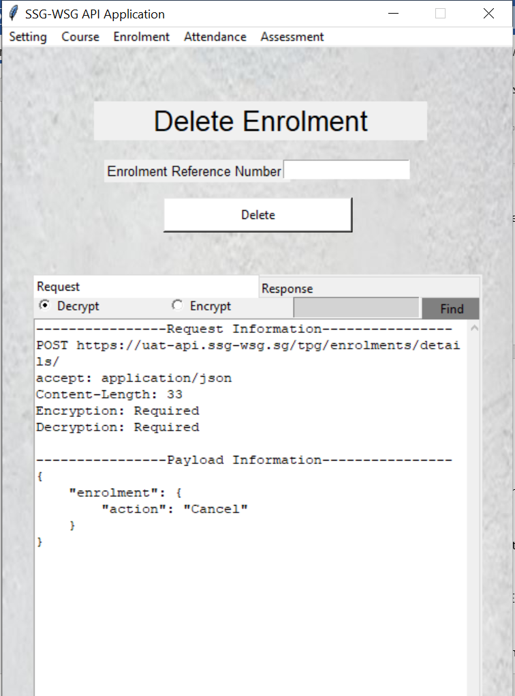

**3**

**2**

Fig. 22: Delete Enrolment API window

1. Key in the Enrolment Reference Number of interest and since this API is a GET Method, there is no payload information required.
2. Click on ‘Delete’ to delete the enrolment.

### Search Enrolment

1. Click on ‘Search Enrolment’ for Search Enrolment window in Fig. 23 to open.

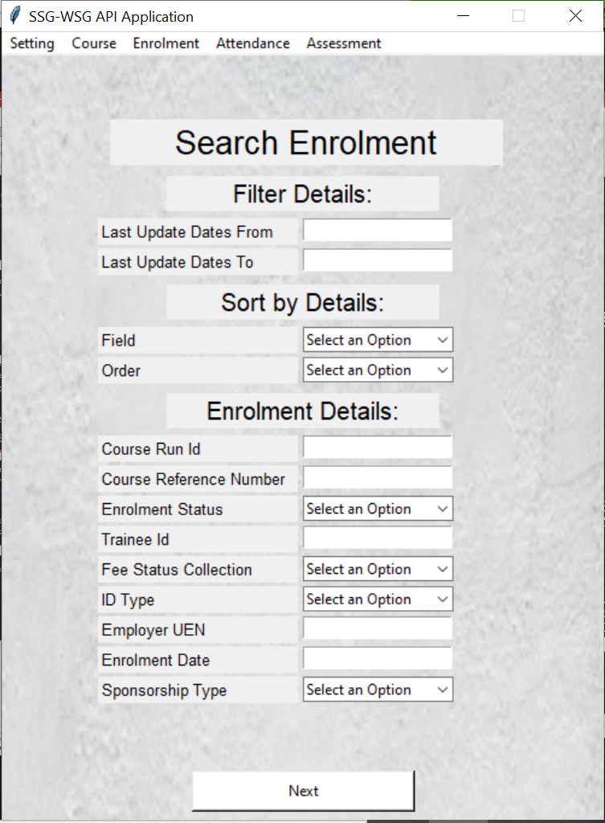

**2**

Fig. 23: Search Enrolment API window

1. Fill up the Request body information that is going to send over to the server. Click on ‘Next’ once all the information is correctly filled in
2. Fill up the Request body information like Training Partner – UEN, TP Code, Number of Pages and Page Sizes that is going to send over to the server.

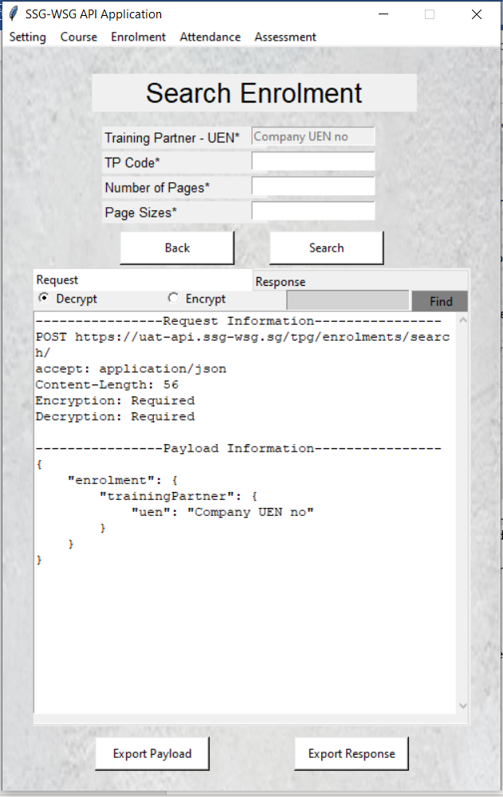

**4**

**3**

Fig. 24: Search Enrolment Preview Request body

1. Click on ‘Search’ once you have ensured that all details of the Request payload are accurate. Click on ‘Back’ if you have further edits to make.

### View Enrolment

1. Click on ‘View Enrolment’ for View Enrolment window in Fig. 25 to open.

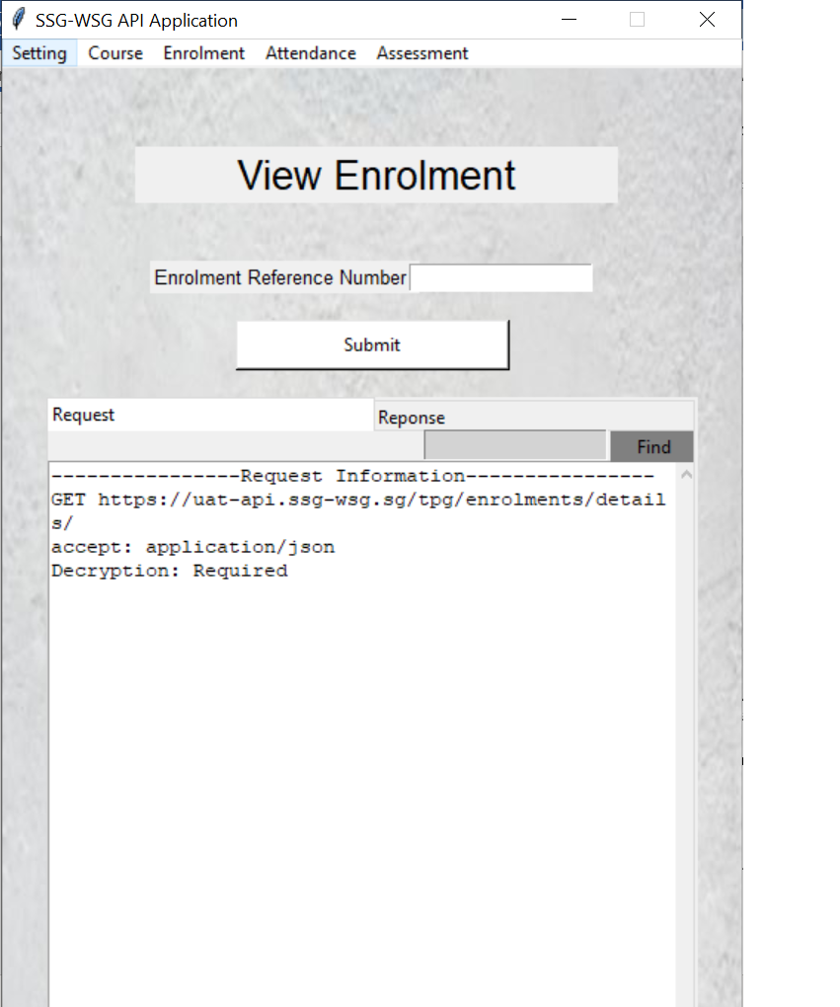

**3**

**2**

Fig. 25: View Enrolment API window

1. Key in the Enrolment Reference Number of interest and since this API is a GET Method, there is no payload information required.
2. Click on ‘Submit’ to view the course sessions.

### Update Enrolment Fee Collection

1. Click on ‘Update Enrolment Fee Collection’ for Update Enrolment Payment Records window in Fig. 26 to open.

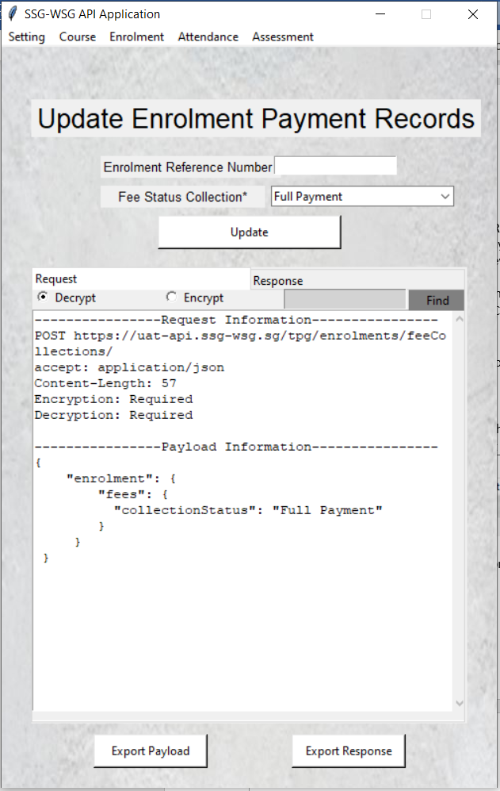

**3**

**2**

Fig. 26: Update Enrolment Fee Collection API window

1. Key in the Enrolment Reference Number of interest and since this API is a GET Method, there is no payload information required.
2. Click on ‘Update’ to view the payment records.

## **Attendance**

### Attendance API

The 2 APIs listed below under this category are implemented in the app.

1. Course Session Attendance - This API is used to retrieve course session attendance information
2. Upload Course Session Attendance - This API is used to upload course session attendance information

Click on Attendance at the top left-hand corner as shown in Fig. 27.

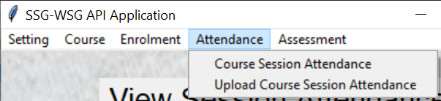

Fig. 27: Attendance APIs

The subsequent sections will take you through the steps needed to use these APIs in the app.

### Course Session Attendance

1. Click on ‘Course Session Attendance’ for View Session Attendance window in Fig. 28 to open.

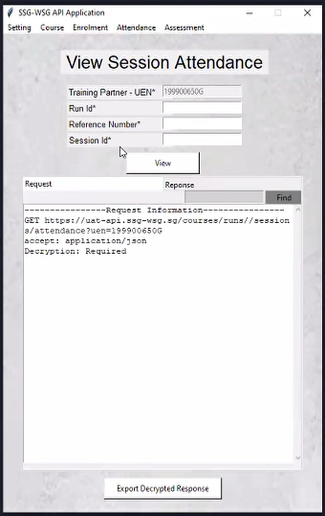

**3**

**2**

Fig. 28: View Session Attendance API window

1. Key in the Training Partner – UEN, Run ID, Reference Number and Session ID of interest and since this API is a GET Method, there is no payload information required.
2. Click on ‘View’ to view the session attendance.

### Upload Course Session Attendance

1. Click on ‘Upload Course Session Attendance’ for Upload Course Session Attendance window in Fig. 29 to open.

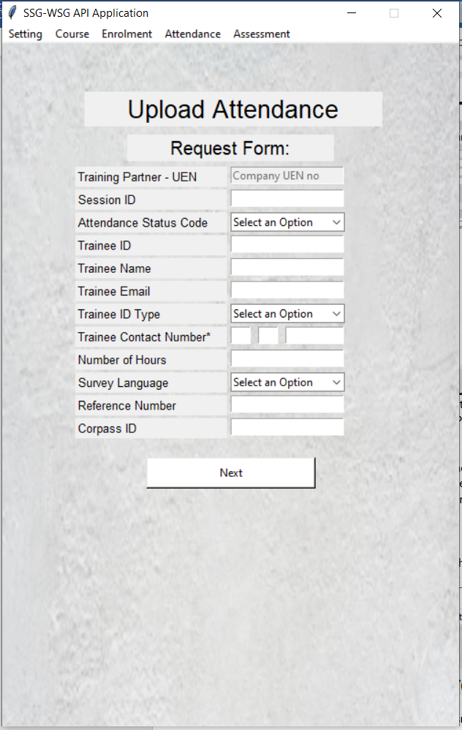

**2**

Fig. 29: Upload Attendance API window

1. Fill up the Request body information that is going to send over to the server. Click on ‘Next’ once all the information is correctly filled in.
2. Fill up the Request body information like Course Run ID that is going to send over to the server.

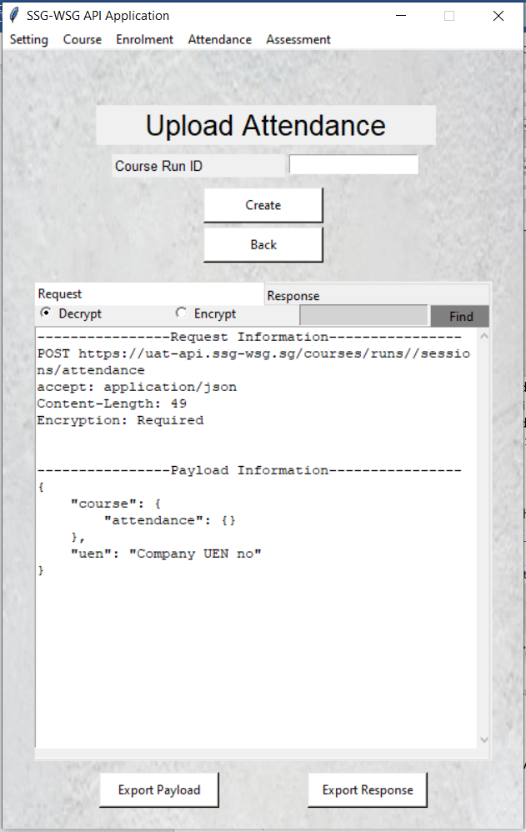

**4**

**3**

Fig. 30: Upload Attendance API preview page

1. Click on ‘Create’ once you have ensured that all details of the Request payload are accurate. Click on ‘Back’ if you have further edits to make.

## **Assessment**

### Assessment API

The 2 APIs listed below under this category are implemented in the app.

1. Create Assessment - Create an assessment record
2. Update or Void Assessment - Update or void an existing assessment record
3. Search Assessment - Retrieve assessment record(s)
4. View Assessment - Search for an assessment record (multiple results or single result)

Click on Attendance at the top left-hand corner as shown in Fig. 31.

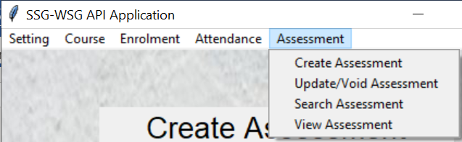

Fig. 31: Assessment APIs

The subsequent sections will take you through the steps needed to use these APIs in the app.

### 

### Create Assessment

1. Click on ‘Create Assessment’ for Create Assessment window in Fig. 32 to open.

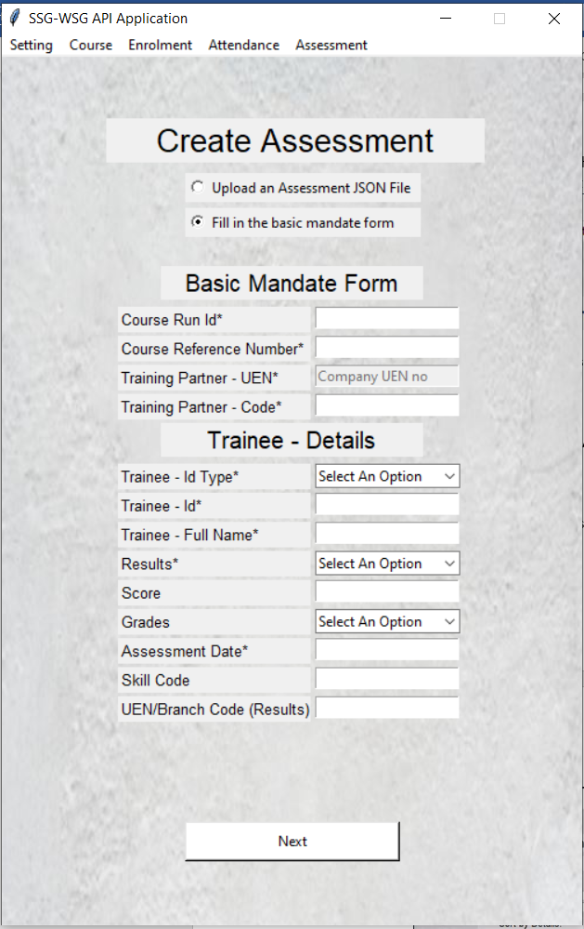

**2**

Fig. 32: Create Assessment API window

1. Fill up the Request body information that is going to send over to the server. Click on ‘Next’ once all the information is correctly filled in.
2. Click on ‘Create’ once you have ensured that all details of the Request payload are accurate. Click on ‘Back’ if you have further edits to make.

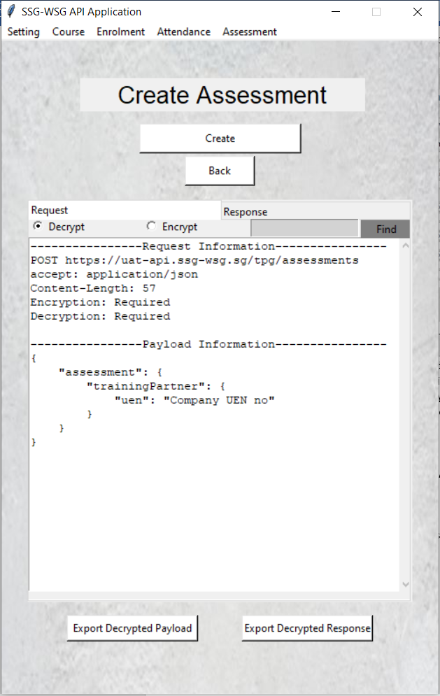

**3**

Fig. 33: Create Assessment API Preview Page

### Update/ Void Assessment

1. Click on ‘Update/Void Assessment’ for Update/Void Assessment window in Fig. 34 to open.

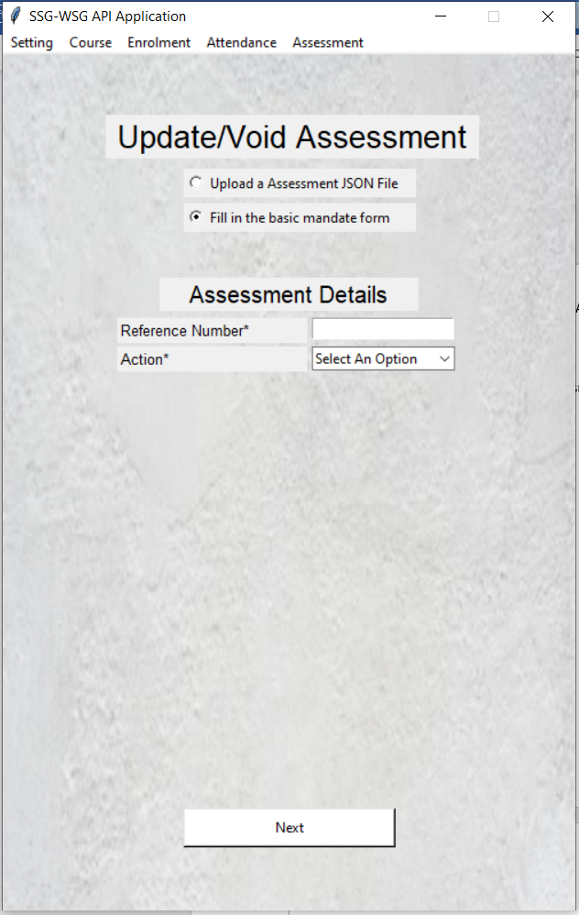

**2**

Fig. 34: Update/ Void Assessment API window

1. Fill up the Request body information that is going to send over to the server. Click on ‘Next’ once all the information is correctly filled in.
2. Click on ‘Update’ once you have ensured that all details of the Request payload are accurate. Click on ‘Back’ if you have further edits to make.

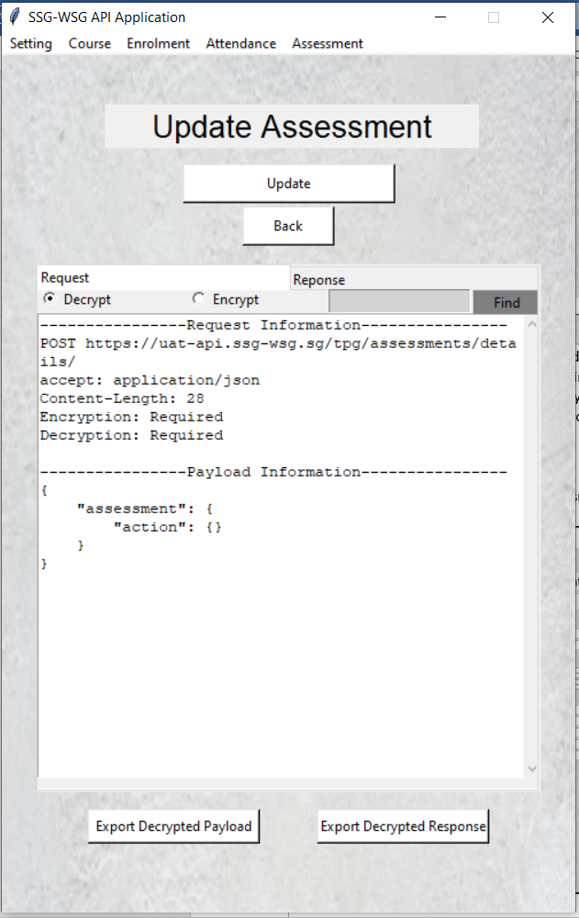

**3**

Fig. 35: Update Assessment API Preview Page

### Search Assessment

1. Click on ‘Search Assessment’ for Search Assessment window in Fig. 36 to open.

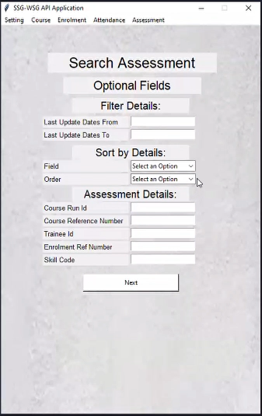

**2**

Fig. 36: Search Assessment API window

1. Fill up the Request body information that is going to send over to the server. Click on ‘Next’ once all the information is correctly filled in.
2. Fill up the Request body information like Training Partner – UEN, TP Code, Number of Pages and Page Sizes that is going to send over to the server.

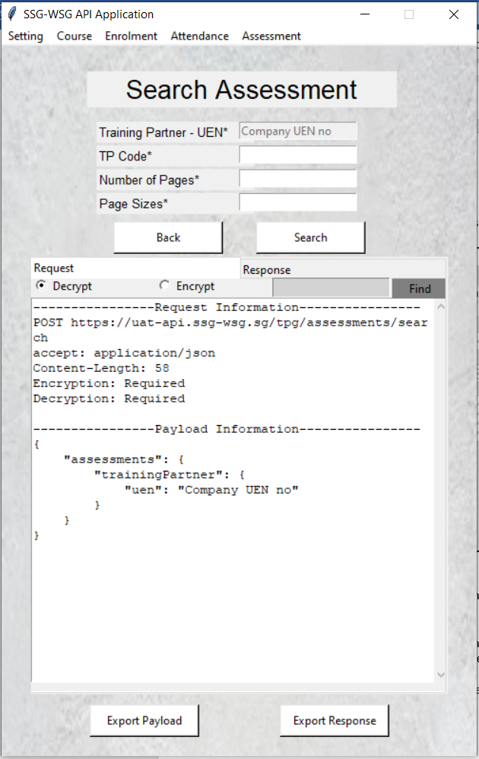

**4**

**3**

Fig. 37: Search Assessment API preview page

1. Click on ‘Search’ once you have ensured that all details of the Request payload are accurate. Click on ‘Back’ if you have further edits to make.

### View Assessment

1. Click on ‘View Assessment’ for View Assessment window in Fig. 38 to open.

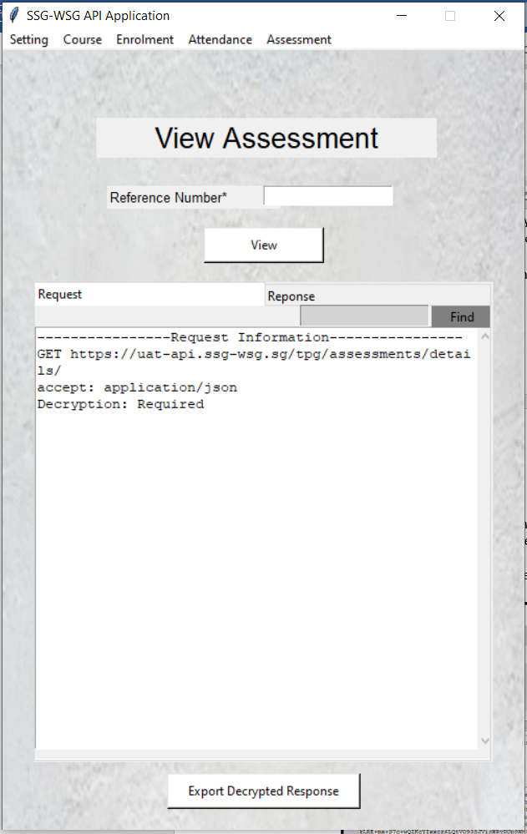

**3**

**2**

Fig. 38: View Assessment API window

1. Key in the Reference Number of interest and since this API is a GET Method, there is no payload information required.
2. Click on ‘View’ to view the assessment.

## **Additional Features**

### 

### Decrypt and Encrypt information

1. Click on ‘Encrypt’ to view the encrypted Request payload/ Response message.
2. Click on ‘Decrypt’ to view the decrypted Request payload/ Response message.

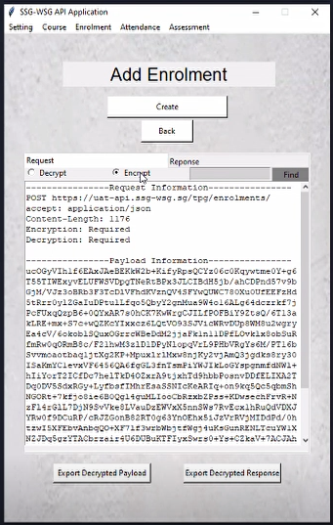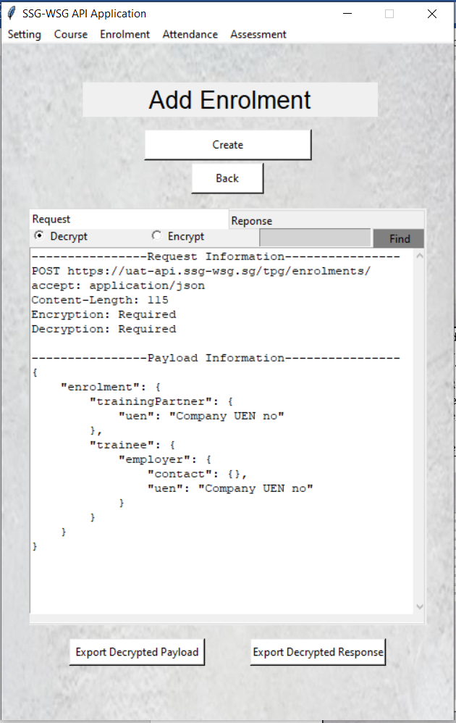

**2**

**1**

Fig. 39: Add Enrolment API Preview Request window

### 

### Tooltip Description

Hover over the fields for a tooltip description if you are unsure on what to key in and the required formatting. An example will be provided.

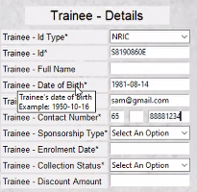

Fig. 40: Example of Tooltip Description feature

### Optional Field and Mandatory Field

Asterisk marks are used to mark out the fields that are required to be filled up to successfully call the APIs.



Fig. 41: Example of Mandatory Field